MNP System
---------------------------------------------------------------------------------------------------------------------------------------------------------------------------
- Description:
Mobile Number Portability (MNP) Business Document – Kingdom of Saudi Arabia (KSA) Specific
Introduction: Mobile Number Portability (MNP) in Saudi Arabia (KSA) allows telecom customers to retain their mobile numbers when switching from one service provider to another. This service is regulated by the Communications, Space & Technology Commission (CST) to enhance competition, improve service quality, and protect consumer rights.
Objectives
• Enable seamless transition between service providers while complying with CST regulations.
• Foster healthy competition within the Saudi telecom sector.
• Improve service quality and customer experience in alignment with national digital transformation goals.
Regulatory Framework
• Governed by CST regulations and policies.
• Ensures fair practices among telecom operators.
• Establishes strict timelines for processing porting requests.
• Mandates transparency in customer communication regarding MNP procedures.
Process Overview in KSA
1. Customer submits a porting request to the new service provider via SMS or service center.
2. The new provider forwards the request to the CST-regulated central database.
3. The existing provider verifies and approves the request within a mandated timeframe.
4. The number is ported within a defined period, typically within 8-24 hours, per CST guidelines.
5. Customer receives a confirmation SMS once porting is completed.
Key Challenges in KSA
• Ensuring minimal service disruption during porting.
• Preventing unauthorized or fraudulent porting requests.
• Maintaining compliance with CST regulations and customer rights policies.
Business Benefits
• Enhanced customer retention and acquisition within a competitive market.
• Encourages service providers to improve offerings and network quality.
• Strengthens trust in the telecom industry through regulatory oversight.
Conclusion MNP in KSA is a crucial component of the telecom sector, empowering customers with the flexibility to choose their preferred provider while ensuring compliance with CST regulations. Ongoing improvements and regulatory enforcement will continue to enhance the MNP process, benefiting both consumers and service providers.

- Infrastructure:

DB server: 10.4.95.44
Username: AppDbAccess
Password: t4v-25QByD
DB name: VirginMNP
Application server: 10.4.1.52
Username: .\Administrator
Password: P#ssw-rd098

- Queries:
select * from NPRequest where msisdnFrom='564887506'
select * from NPRequest where portID=’ P202411091840526785’
Here we use this query to check the MNP request type if its port in or port out and check the request status or stage.
In the same table you can find the IMSI for the customer, ID number, ID type, Doner and receiver.
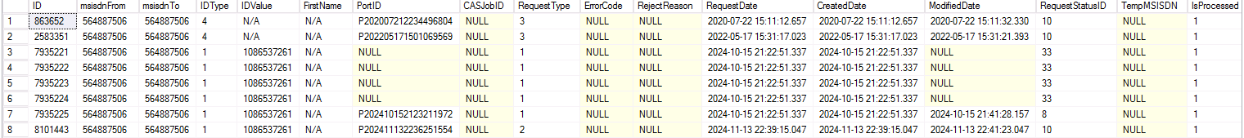

select * from NPActivity where PortID='P202411091840526785' order by 1 desc
Here you can Find the calls that happened between the operators and Doners and Virgin Mobile with message id for each API call as below screenshot:
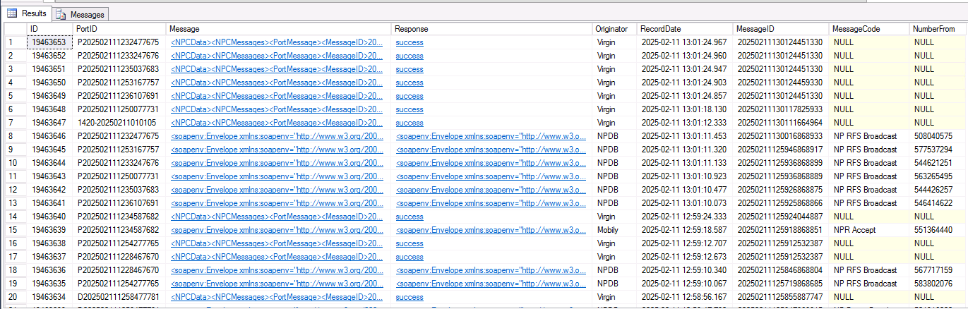
select * from WorkflowInstance where NPRequestID=8077386 order by 1 desc
in this table you can find the workflow that the number working on and what is the parameters for this workflow and the action that the done for the number and if it successful or not as below screenshot:
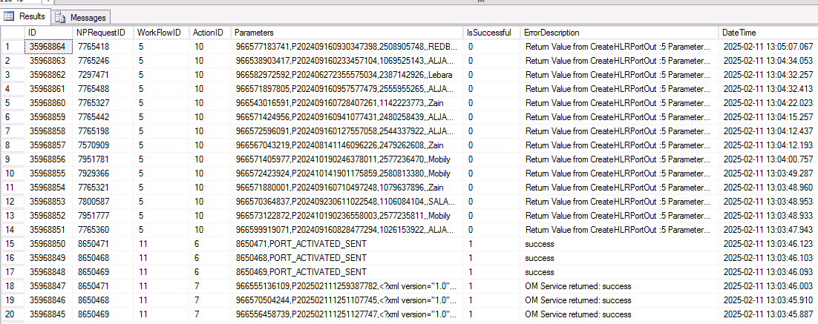

select top 100 * from ErrorLog order by 1 desc
To check the errors that happened for each request
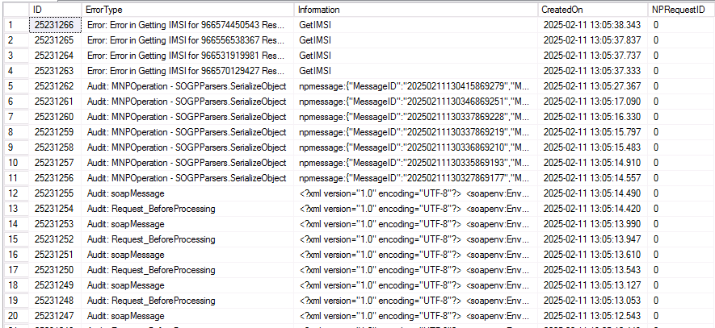

Select * from NumbersQuarantine order by 1 desc
If we have ported in a number and terminated in our system, the mnp system insert it on this table to return this number after 3 months if the customer doesn’t port in reactivation.
